Foundation „Encounters. Foundation for German-Palestinian Youth Exchange”
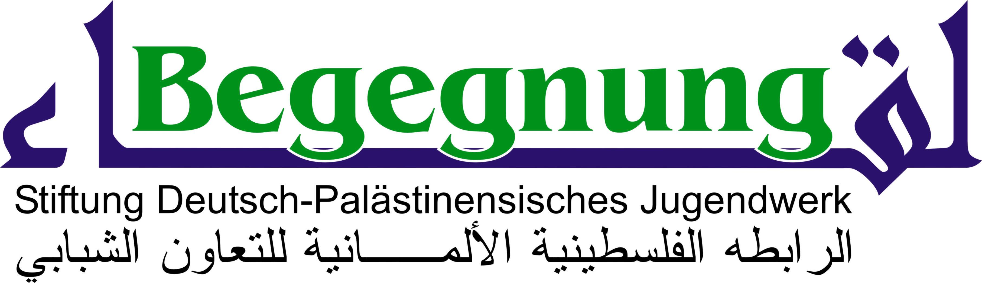
is mourning Juliano Mer Khamis

On April 4th 2011, the 52 year-old director and founder of the Freedom Theatre in the Palestinian refugee camp of Jenin was shot five times by a masked killer upon leaving the theatre. This news has left us shocked and speechless. We are mourning a committed man and artist, an indefatigable and brave fighter for freedom and a just peace in Israel and Palestine.
Juliano Mer Khamis, the son of a Palestinian father and the Israeli actress Arna Mer, set up an exemplary theatre-project in 2005. On the ruins of the Stone Theatre, founded by his mother and destroyed by Israeli forces in 2002, he founded and directed the Freedom Theatre and the affiliated Actors School for young Palestinians in the Jenin refugee camp.
Mer Khamis was a visionary and an ambassador for a youth without hope in the refugee camp. He succeeded in showing traumatized youngsters new perspectives and hope for a life in peace without any kind of violence. Instead of weapons he opened their mind to the possibilities of nonviolent resistance with the instruments of the theatre. For these young people he sacrificed his entire strength and in the end his life.
We personally got to know Juliano Mer Khamis in Gütersloh. His visit with the Freedom Theatre on September 23rd 2009 in the old Weaving Mill in Gütersloh remains unforgettable. His Freedom Theatre was invited there by Foundation “Encounters” during its first tour in Germany.
The committed director and his young actors presented their production “Fragments of Palestine”. That evening we were deeply impressed by of their commitment and passion. Juliano Mer Khamis and his ensemble did a fantastic job. The local newspaper “Die Glocke” wrote: “The audience in Gütersloh was genuinely touched.” In the subsequent talk with the audience, Juliano Mer Khamis said: “By giving them the opportunity to join this group, we succeeded in giving young people new self-confidence and a space for their dreams.”
Some weeks ago the Municipal Theatre of Gütersloh and Foundation “Encounters” invited the ensemble of the Freedom Theatre to give another performance in Gütersloh. The date for this performance has already been printed in the new program of the Theatre: Friday, October 7th, 2011. We want to encourage the young actors and actresses of the Freedom Theatre to carry on the work of Juliano during their tour in Germany in the autumn of 2011.
We are mourning Juliano Mer Khamis and share the pain of his family and his friends, the ensemble of the theatre and the children and young people of the Freedom Theatre in Jenin.
The Foundation “Encounters” wants to help to keep Juliano’s message alive. Thank you, shukran Juliano!
In the name of the founders
Marita Kappler
Chairwoman

