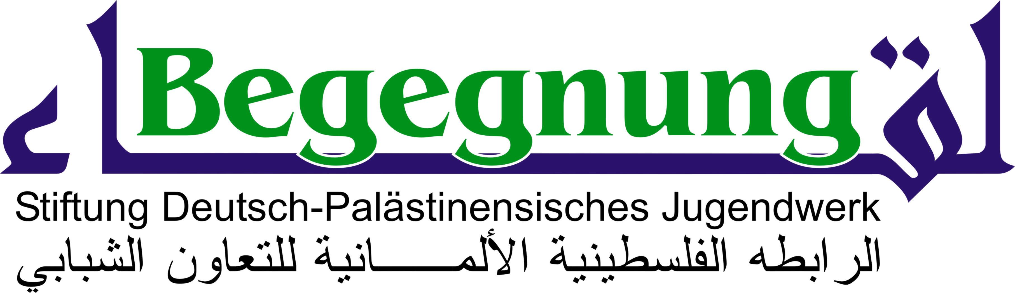
ZONTA INTERNATIONAL Zonta International


Zonta Club Bielefeld
Practical Training in Germany
Summer 2020
Begegnung. Stiftung
Deutsch-Palästinensisches Jugendwerk
Marita Kappler Chairwoman
August-Verleger-Weg 38
D-33332 Gütersloh
Tel. 0049 (0) 5241-470851
MaritaKappler@web.de

for young women from Palestine

Gütersloh, December 2019
In summer 2020, the German Foundation “Begegnung“ (Encounters) in cooperation with the “Zonta Club” (in the city of Bielefeld) can offer two scholarships (internships) to young Palestinian women. Ideally, this would be young women who studied four years and will finished the studies in 2021.
Young women who will finish their studies already in Juni 2020 cannot apply, because they will not get the visa for
foreign students.
Working place
There will be internship positions offered in the city of Bielefeld (northwestern part of Germany) for the period of approx. 9-10 weeks.
Dates
Approx. from the end of June until the end of August or beginning of September 2020.
Accomodation
The “Zonta Club” and foundation “Begegnung” will make all necessary arrangements, including appropriate accommodation (either at the student’s dormitory in Bielefeld or alternativly in a private appartement in a family house).
Financial support
The costs of the flight (airplane ticket) and medical insurance will be paid directly by the above mentioned organizations, as well as the expenses for accomodation. Additionally, the amount of 400 € per month will be payed directly to the trainees for living expenses and pocket money (in case of living in a private appartment this ammount will be reduced to 360 € per month.)
Terms of selection of the trainees
- Good or very good graduation degrees
- Good or very good English language
- Social background of the special cultural and political situation in Palestine:
Social, cultural, enviromental or other engagement for the Palestinian society, for other Palestinian people
- German language is not a requirement (could be helpful in some cases).
Giving young women the opportunity to conduct a practical training in Germany is not only for helping them build a career, but also develop the society in Palestine und build contacts between the peoples in Germany and Palestine. Therefore, the trainees will be asked to give a public presentation about their lives and the situation of young people
in Palestine. This presentation can be held in English.
Evaluation: After the end of the internship, the trainees will be asked to provide a written report on their visit and the training they received in order to help improving the training programme in future.
Please send the applications until January, 12th 2020 (please use the attachmed application form). The applications can be sent by email to: MaritaKappler@web.de For further inquaieries please contact Mrs. Marita Kappler.
Best wishes and greetings from Germany
Marita Kappler
Chairwoman of Foundation “Begegnung“

Zonta Club Bielefeld, Präsidentin: Murielle Guéguen, Vizepräsidentin Inka Noack , www. zonta-bielefeld.de
BEGEGNUNG. Stiftung Deutsch-Palästinensisches Jugendwerk, Vorstand: Dr. Doris Hess-Diebäcker, Marita Kappler (Vorsitz),
Pfarrer Martin Liebschwager, Dr. Bashar Shammout, Gunar Weykam, Homepage: www.stiftungbegegnung.

The two supervising organizations:

The nationwide charitable foundation ENCOUNTER. The German-Palestinian Youth Foundation
(seat in Gütersloh) was founded, among other things, on an initiative of the Anne Frank School Gütersloh,
which has been carrying out a German-Palestinian exchange of students with the partner school School
of Hope in Ramallah for many years. Foundation initiators are private individuals from Gütersloh and
the Ev. Luth. Parish Harsewinkel as well as the association project. Friendship Münster Working Group
for Peace in Palestine and Israel e.V .. The Foundation wants to support in many ways projects that
serve the understanding between young Germans and Palestinians and promote intercultural dialogue, tolerance and non-violent and democratic interaction with others.

The Zonta Club Bielefeld is one of Zonta International's approximately 120 German Zonta Clubs,
a worldwide, non-denominational, non-denominational and ideologically neutral network of
self-employed and working women in responsible positions. The seat is in Chicago. The aim is to
support and promote women and girls in their jobs and in society. An essential aspect of Zonta
International is also the cultivation of friendship and mutual help. Zonta International is committed
to respecting human rights, justice and international understanding.

